**MAKERERE UNIVERSITY**

**SCHOOL OF COMPUTING AND INFORMATION TECHNOLOGY**

**RECESS PROJECT**

**DJANGO FEEDBACK SYSTEM**

**DOCUMENT**

Table of contents

**1.** **Introduction** 1

**2.** **Problem statement** 1

**3.** **Student** 2

**4.** **Administrator** 3

**3.1 Log in component** 3

**3.1.1 Log in** 3

**3.2 Components** 5

**3.2.1 Course feedback form** 5

**3.2.2 Course table** 5

**3.2.3 Instructor feedback form** 6

3.2.4 **Instructor table** 7

**3.2.5 Facility feedback form** 8

**3.2.6 Facility table** 8

**3. 3.1 Register** 9

# **Introduction**

The Django Feedback System deals in gathering student feedback about courses, instructors and campus facilities to improve educational services. It aims at providing administrators and faculty members with insightful data for analysis and decision-making and enhancing the overall learning experience and campus environment through student assessing courses, instructors and facilities.

The system is used by two users namely

* Administrator
* Student

The administrator is the one who views the assessments done by students.

The student according to the system is the person who provides feedback by filling different forms on the system.

All the users use the web interface to access the system. Each user is provided with different system components depending on the user authorization as this will be discussed below.

# **Problem statement**

The Student Feedback System aims to address the lack of an efficient and comprehensive feedback mechanism at our educational institution. Currently, the process of gathering and utilizing feedback from students is ad-hoc, leading to a fragmented and inconsistent approach in understanding the learning experience, faculty performance, and institutional effectiveness. This report seeks to analyze the implementation and impact of the system, identifying challenges and proposing recommendations to improve its efficacy and foster a culture of continuous improvement in teaching and learning.

# **Student**

On loading of the system by the server, the home page is displayed. Below is a figure which shows how the home page looks.

***Figure 2.1.1 home page***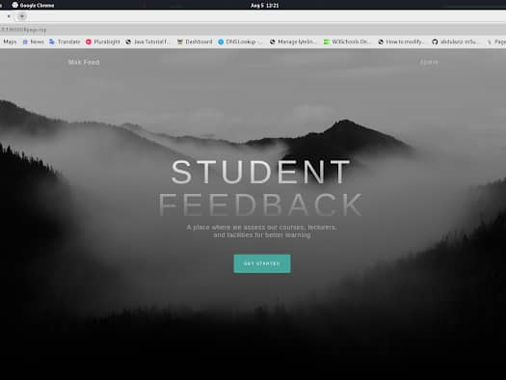

The students are free to provide their details in order for them to give their assessment about their course, instructor and facility as shown in the figure below.

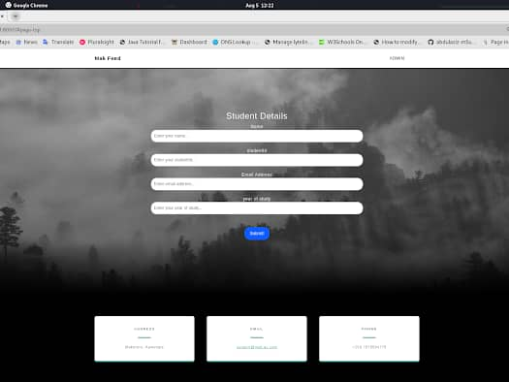

***Figure 2.1.2 students’ login page***

* Fill the course feedback form
* Fill the instructor feedback form
* Fill the facility feedback form

However, the student can as well provide his credentials and use the system though it is not mandatory.

# **Administrator**

The administrator according to the system is the person who manages the forms filled by the students.

The administrator registers into the system by signing up with the credentials, logs in, views performance, checks the instructor, course and facility tables and logs out.

## **3.1 Log in component**

### **3.1.1 Log in**

The administrator clicks on the login icon on the homepage in order to go to the login page as shown below in the figure.

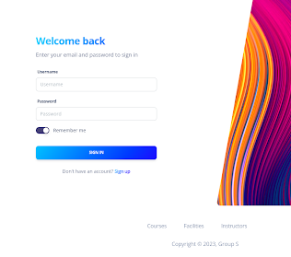

***Figure 3.1 Log in interface***

The “remember me” button is to ensure that the system keeps your credentials such that the next time the administrator does not need to enter them manually.

The figure below shows the admin dashboard on logging in for the administrator.

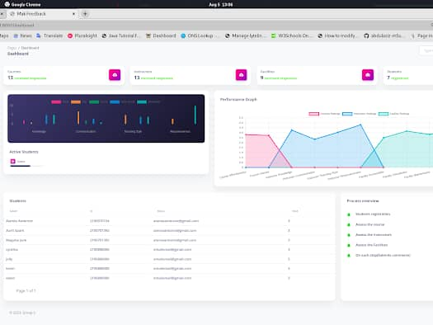

***Figure 3.2 Administrator dashboard***

## **3.2 Components**

### **3.2.1 Course feedback form**

This contains the different attributes such as Course name, Course code, Course description, effectiveness, interest and improvement and it is filled by students to assess the course.

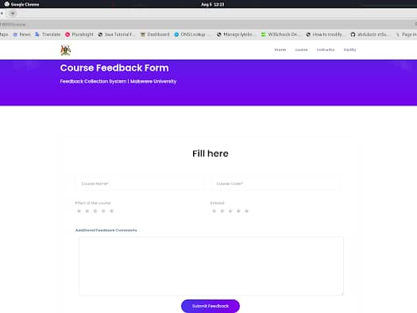

***Figure 3.3 Course feedback form***

### **3.2.2 Course table**

This is found on the administrator page and it contains information which students filled about the course. The chart shows the analysis made from the data collected from students.

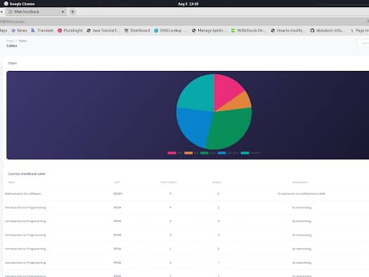

***Figure 3.4 Course table***

### **3.2.3 Instructor feedback form**

This is found on the student’s page where they fill information about the name, department, course unit, knowledge, communication, teaching style, responsiveness, additional comments of the instructor.

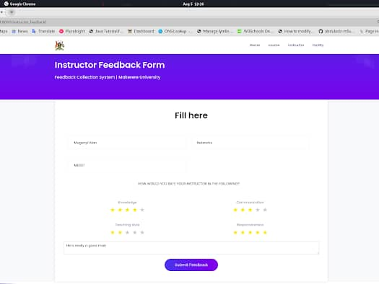

***Figure 3.5 the instructor feedback form***

### 3.2.4 **Instructor table**

This is found on the administrator page and it contains information which students filled out about the instructor.

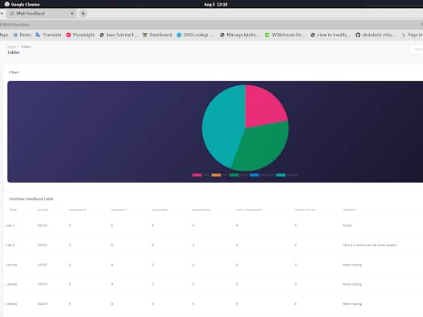

***Figure 3.6 the instructor table***

### **3.2.5 Facility feedback form**

This is found on the student’s page where they fill information about the name, department, course unit, knowledge, communication, teaching style, responsiveness, additional comments of the instructor.

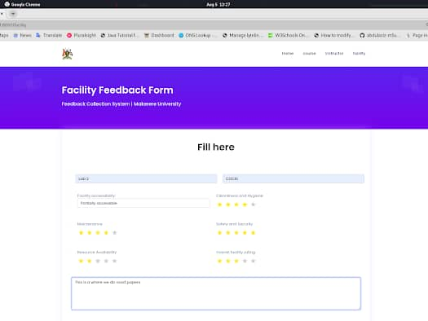

***Figure 3.7 facility feedback form***

### **3.2.6 Facility table**

This is found on the administrator page and it contains information which students filled out about the instructor.

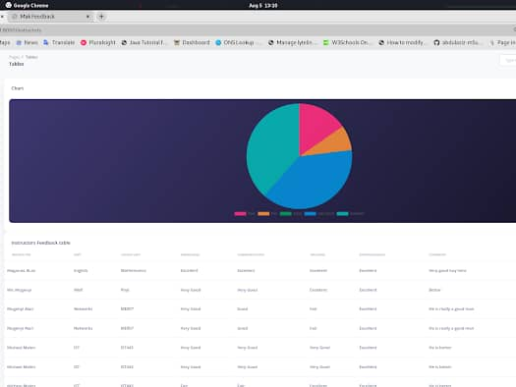

***Figure 3.8 facility table***

### **3. 3.1 Register**

This is for the administrator who does not have an account to create one and sign up.

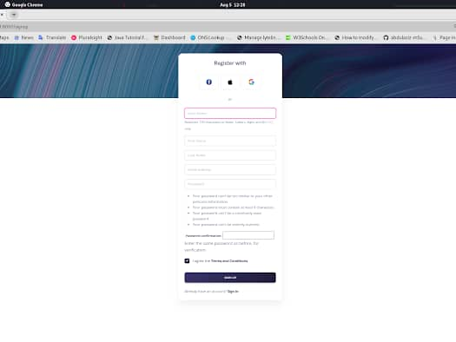

***Figure 3.9 Register interface***